МИНИСТЕРСТВО ОБРАЗОВАНИЯ И НАУКИ

РОССИЙСКОЙ ФЕДЕРАЦИИ

ФЕДЕРАЛЬНОЕ ГОСУДАРСТВЕННОЕ АВТОНОМНОЕ ОБРАЗОВАТЕЛЬНОЕ УЧРЕЖДЕНИЕ ВЫСШЕГО ОБРАЗОВАНИЯ

«САМАРСКИЙ НАЦИОНАЛЬНЫЙ ИССЛЕДОВАТЕЛЬСКИЙ

УНИВЕРСИТЕТ ИМЕНИ АКАДЕМИКА С.П. КОРОЛЕВА»

Институт информатики и кибернетики

Факультет информатики

Кафедра геоинформатики и информационной безопасности

Отчёт по лабораторной работе №2

«Git and CI»

Выполнила: Чекушкина В.А.

Группа: 6412-100503D

Проверил: Авдеев Е.В.

Самара 2023

**TASK**

1. Gitlab setup (on VM/Docker/Minikube) (VM variant) Download Gitlab-Bitnami vm image from <https://bitnami.com/stack/gitlab/virtual-machine>.
2. Create repo in gitlab with sources of your app Upload  <https://github.com/olindata/sample-gitlabci-cpp-project> to your Gitlab server.
3. Setup runner (Gitlab, Docker, Jenkins, ArgroCD).
4. Edit .gitlab-ci.yml to run runner in shell mode (without Docker).
5. Run Pipeline: **CI/CD > Pipelines > Run pipeline.**

****PROCESS OF WORK****

1. From the website https://bitnami.com/stack/gitlab/virtual-machine the Virtual Machine image was downloaded and imported into the VirtualBox virtual machine.

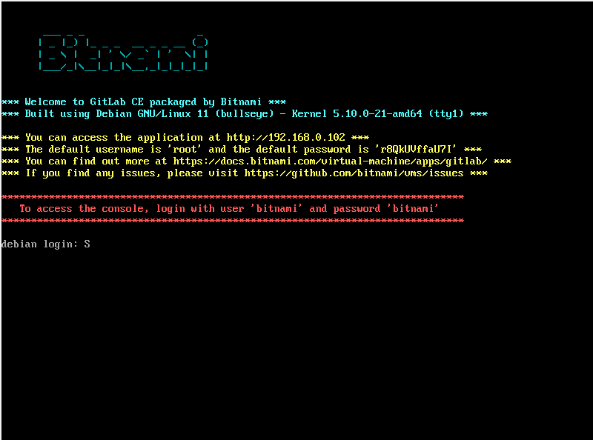

By clicking on the link https://192.168.0.104 / and after authenticating using the proposed *root* login and password *r8QkUVffaU7I*, we get to the GitLab page:

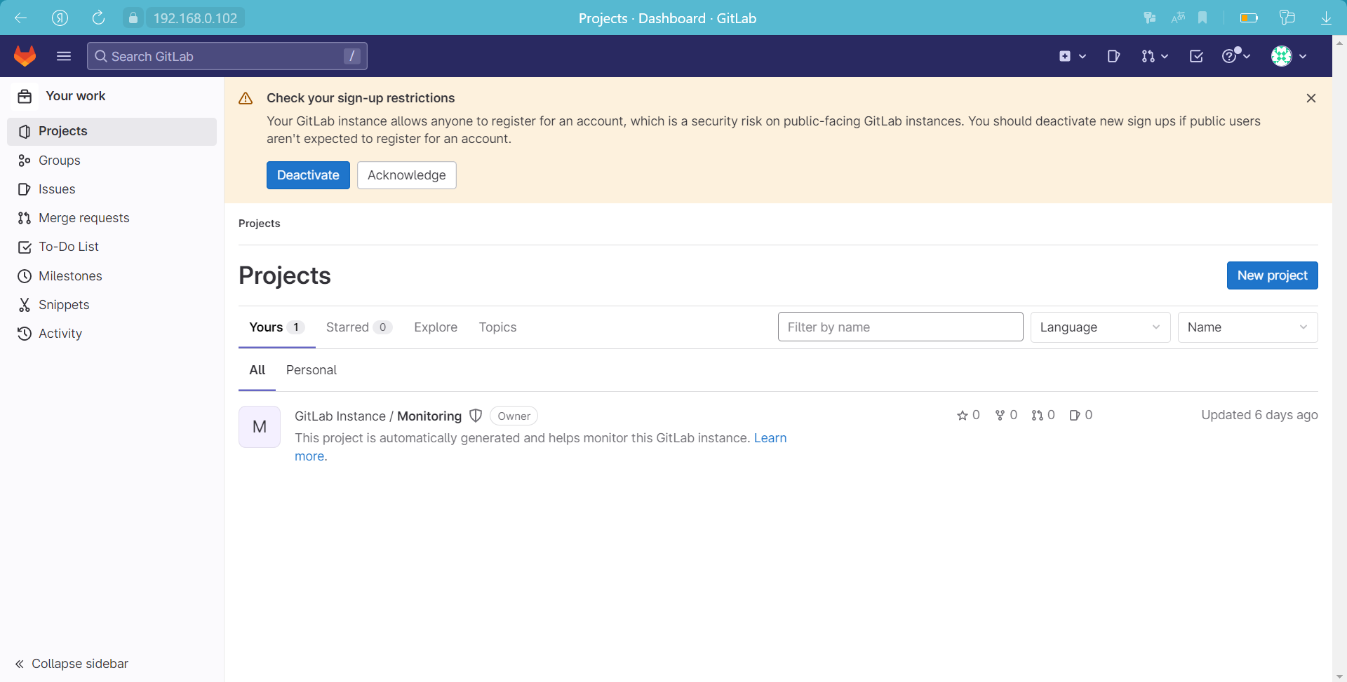

1. Cloning the repository from the site https://github.com/olindata/sample-gitlabci-cpp-project to the computer

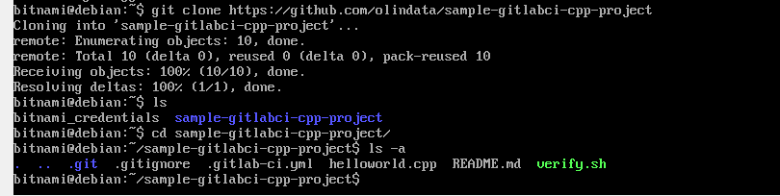

Let's create an empty private project in GitLab and copy it to the computer:

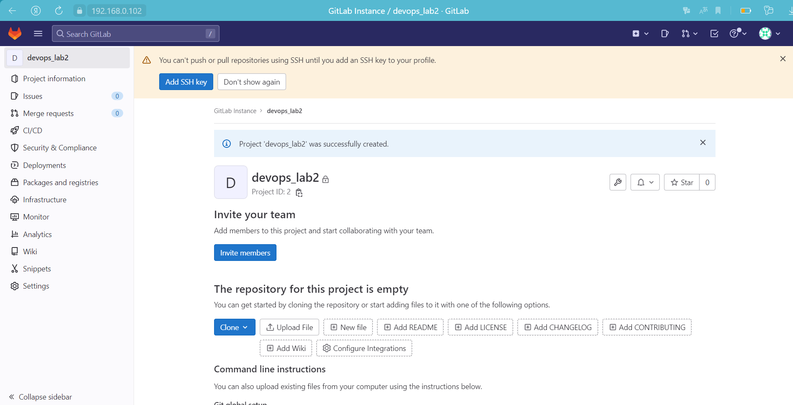

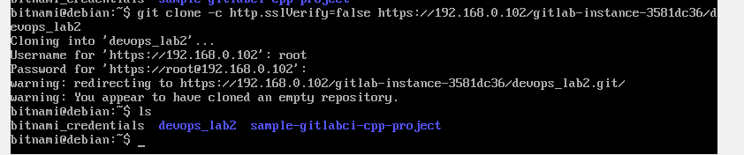

Unblock SSH:

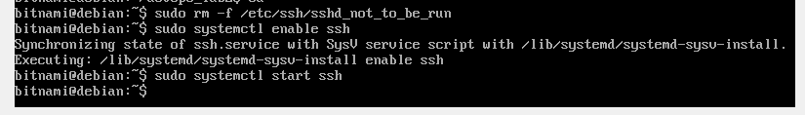

In the /etc/ssh/sshd_config file, change the PasswordAuthentication and ChallengeResponseAuthentication parameters to yes and restart the ssh service:

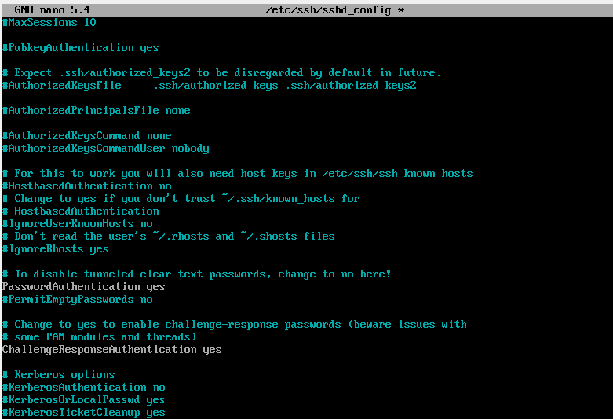

Next, copy the contents from the sample-gitlab ci-cpp-project folder to the devops_lab2 folder and upload the changes to the repository:

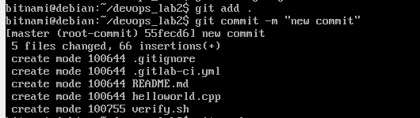

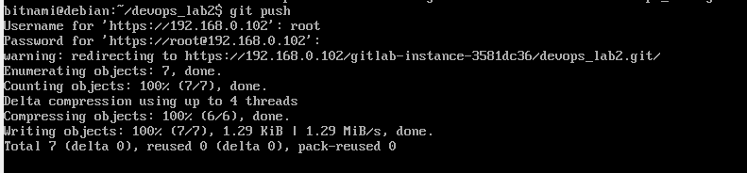

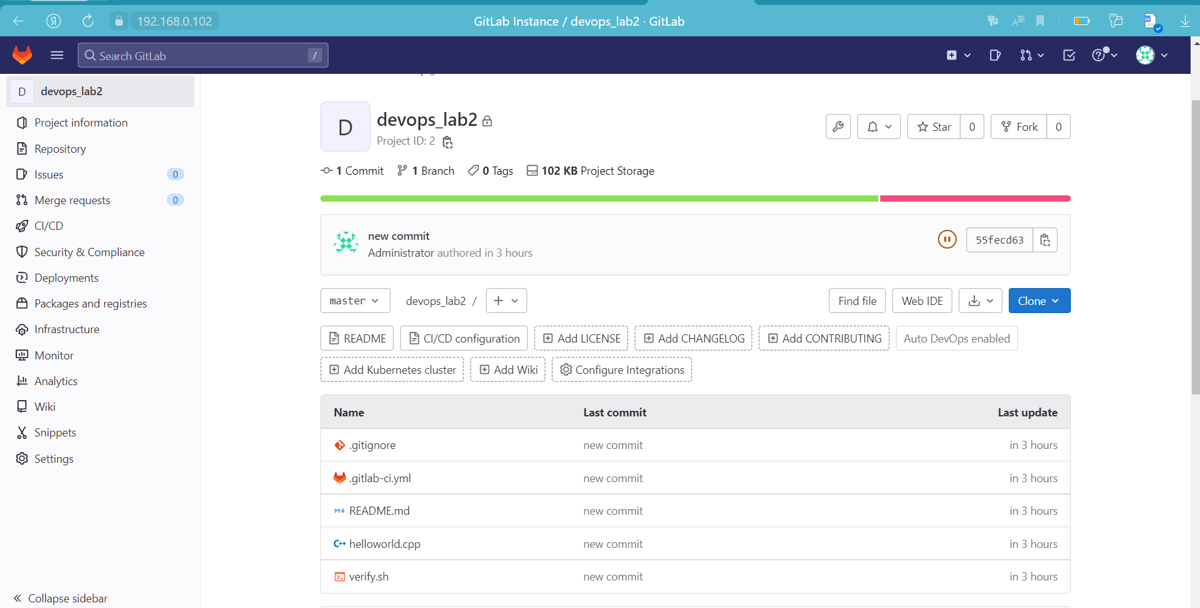

1. Install gitlab-runner

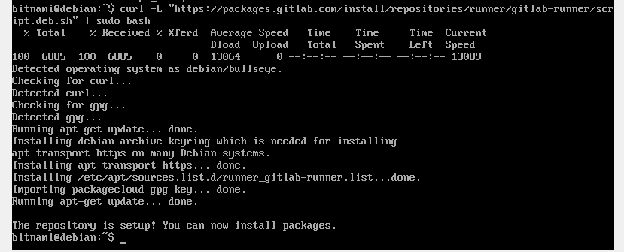

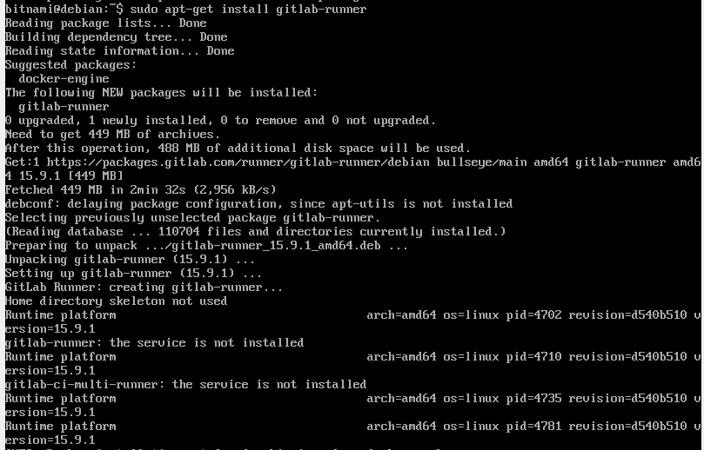

Let's change the parameters in the /etc/gitlab/gitlab.rb file:

* external_url 'http://192.168.0.2'
* nginx['redirect_http_to_https'] = false
* nginx['ssl_verify_client'] = "off"

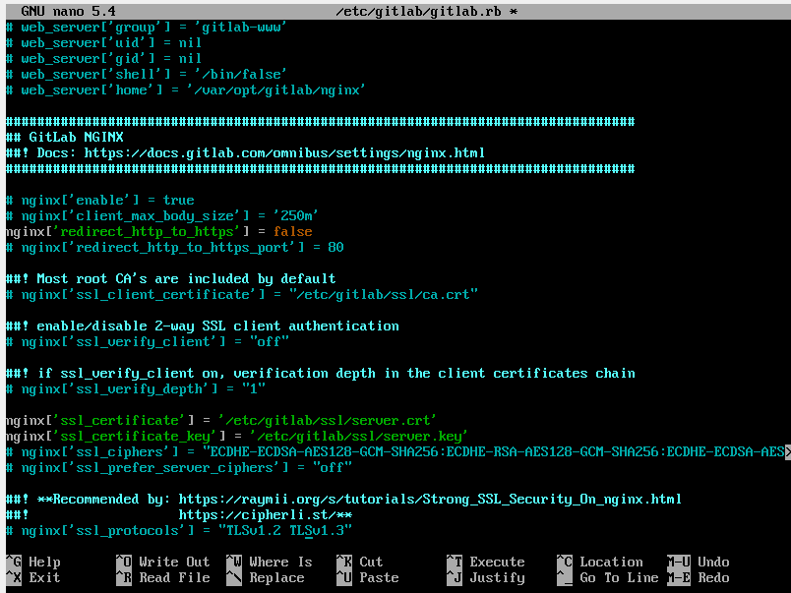

Using the sudo gitlab-ci reconfigure command, we will reconfigure the file we just edited, and then register GitLab Runner:

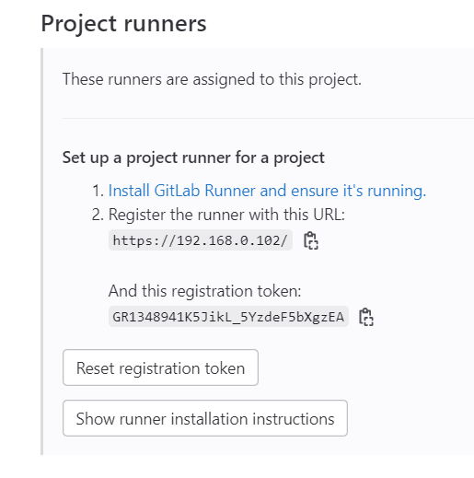

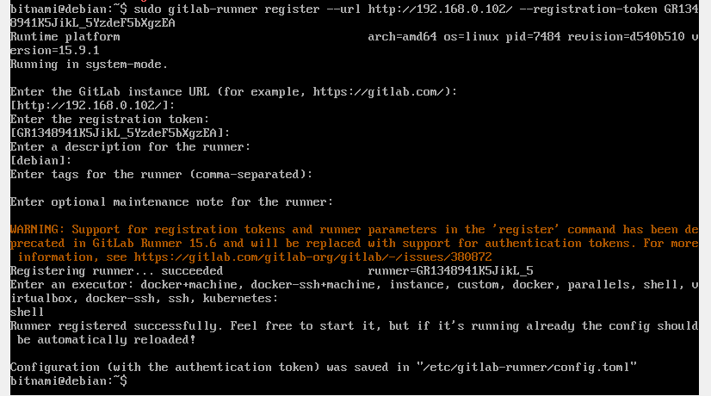

1. Editing the file .gitlab-ci.yml:

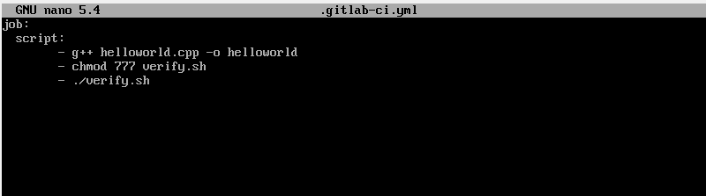

Upload the changes to the repository:

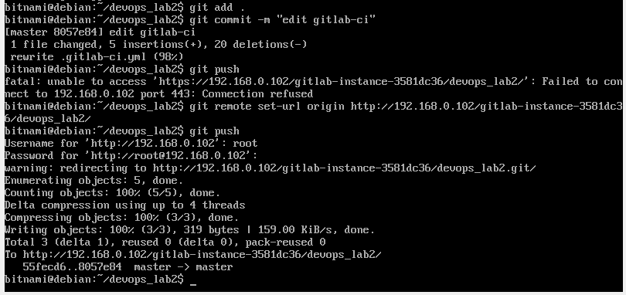

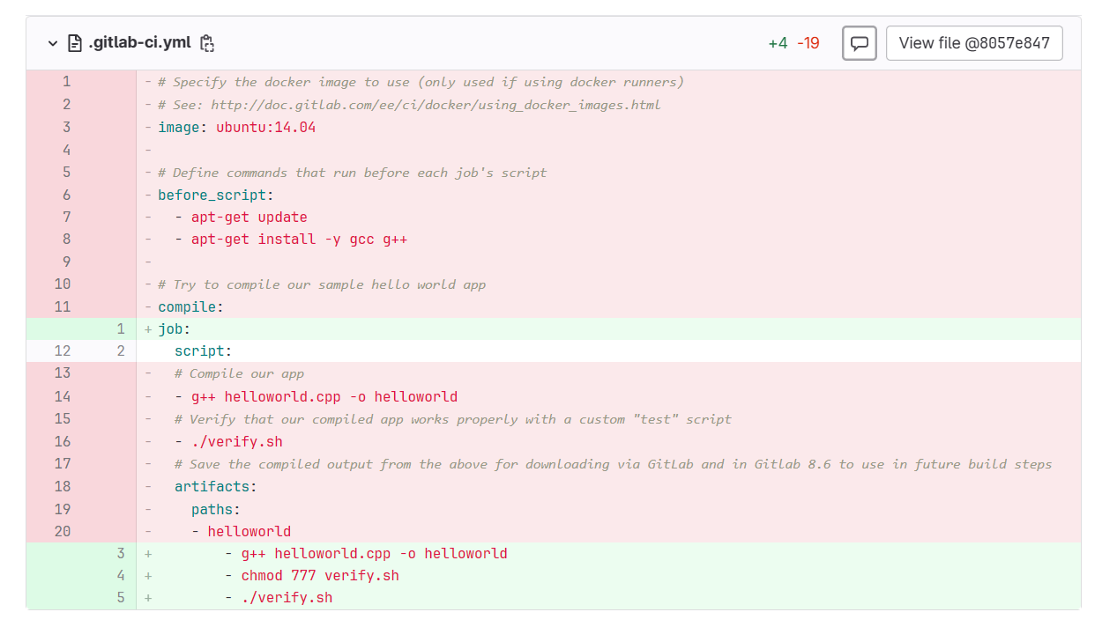

1. Let's start the Pipeline:

